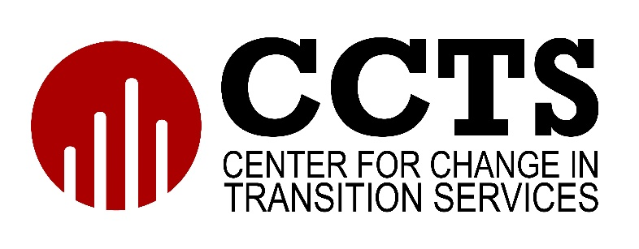

Partnerships for Inclusion: SE and CTE Workbook
This workbook is designed for use with the Partnerships for Inclusion: Special Education (SE) and Career Technical Education (CTE) training course from the Center for Change in Transition Services (CCTS).

Module 1: Introduction to Inclusionary Practices

Activity 1
Consider your school or district’s current strengths in inclusionary practices. Indicate which are in-place, in-progress, or non-existent.
Inclusionary Practice Strengths | In-place | In-progress | Non-existent
Inclusive Vision and Practice
Growth Mindset
Supported by Research
Presumed Competence
Practice of Differentiation and Universal Design for Learning (UDL)

Activity 2
- What is your school or district doing to support the practices that are in-place?

- Think about the areas that are in-progress or non-existent. How might your school or district improve or begin this work?

Extension Activity
What efforts are you currently taking to actively communicate with parents and families about inclusive practices?

Module 2: Developing Partnerships between Special Education (SE) and Career Technical Education (CTE)

Activity 1
Provide an example of SE and CTE collaboration or partnership in your school.

Activity 2
After watching the videos for this module, describe two ways to build or sustain collaboration between SE and CTE.

Extension Activity
If you are a SE teacher, meet with a CTE teacher. If you are a CTE teacher, meet with a SE teacher. Share your thoughts from Activity 2. Discuss with them their perceptions of collaboration and partnership between SE and CTE. Record key takeaways from the conversation here.

Module 3: Transition Plans and Career Technical Education (CTE) Course Enrollment

Activity 1
A student with an IEP is enrolled in CTE courses. What information does the CTE teacher need to know about the student and where can they find that information?

Activity 2
- How does the IEP transition plan align with the HSBP?

- What is one main component of each plan?

Extension Activity
How does your school ensure that IEP transition plans and HSBP align? Talk to your school counselors, SE and CTE teachers, and students to better understand how this happens or how to strengthen this process. Record key takeaways from the conversation here.

Module 4: Co-teaching for Special Education (SE) and Career Technical Education (CTE)

Activity 1
- What are two benefits of co-teaching for students with disabilities?

- What are two benefits of co-teaching for teachers?

Activity 2
Which of the following models of co-teaching have you used or are most familiar with in your school?
- Team Teaching
- Station Teaching
- One Teach, One Observe
- Alternative Teaching
- Parallel Teaching
- One Teach, One Assist

Extension Activity
- What steps has your school taken to implement co-teaching?

- If co-teaching is in place, what are the next steps to improve and sustain these practices?

Module 5: Implementing Change

Activity 1
Describe a process of complex change that your school is envisioning or implementing to increase inclusionary practices for students with disabilities.

Activity 2
As you think about this change as described in the previous activity, review the Complex Change Matrix. Which of the five components are strongest, and which are missing?

Extension Activity
Review the video “Clover Park’s Journey” (13:30) and discuss this with a partner or team. What did you learn from the video that you might use to strengthen your work in your school?

