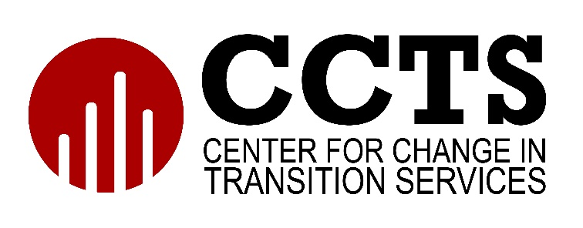

WETP Workbook

This workbook is designed to be used alongside the CCTS Writing Effective Transition Plans (WETP) online training modules.

Last updated August, 2022

Module 1: Introduction

Activity 1
- How would you describe transition planning to a parent and student?

- When must transition planning be included in the IEP?

Activity 2
Review the Transition Services Flowchart.
- Is this the sequence you use in developing a transition plan?

- If not, what is different?

Extension Activity (Optional)
Visit the CCTS website and explore the most recent PSO data.
- View state-level PSO data
- View PSO data by ESD and county
Reflect on your findings.
- What stands out to you?

- What are you curious about?

- What are your thoughts about how we can change the outcomes?

Module 2: Age-Appropriate Transition Assessments

Activity 1
List three ways you currently gather information on strengths, needs, interests, and preferences for your students.

Activity 2
How can you include or improve students’ involvement in the transition assessment process?

Extension Activity (Optional)
- Talk to a student with an IEP about their transition plan.
- Review the transition assessments included in the IEP.
- Did the student participate in gathering this information? If so, how?

Module 3: Postsecondary Goals

Activity
Locate the postsecondary goals on your IEP.
- Are there measurable postsecondary goals for education/training?

- Are there measurable postsecondary goals for employment?

- Are there measurable postsecondary goals for independent living?

- Are the postsecondary goals based on age-appropriate transition assessments? How do you know this?

Extension Activity (Optional)
Talk to a student receiving special education services about their postsecondary goals as written in their IEP.
- Discuss with them how the goals were determined.
- Discuss with them if these still represent their goals for life after high school.
- Record any key takeaways from the conversation here.

Module 4: Identify Transition Services

Activity
Review an IEP that you created or a sample IEP. Locate the transition services section.
- Does the IEP contain transition services?

- Are the transition services related to the age-appropriate transition assessment? If so, how?

- Do the transition services align with the postsecondary goals? If not, how might you modify them?

Extension Activity (Optional)
Talk to a student receiving special education services about the transition services documented in their IEP.
- Was the student aware of these services as written in the IEP?

- Are they receiving the services?

Module 5: Course of Study

Activity
Review the course of study in an IEP that you have written or look at a sample IEP.
- Is the course of study for one year or for multiple years (it can be either)?

- Describe how the course of study supports the postsecondary goals.

Extension Activity (Optional)
Meet with a school counselor. Share and discuss information about the course of study in the transition plan.
- Was the school counselor aware that this information was included in an IEP?

- Has the school counselor participated in developing the course of study for a student either by providing information or consultation or by attending the IEP meeting?

Module 6: Annual Goals

Activity 1
Compare and contrast annual goals and postsecondary goals.

Activity 2
Review the annual goals in an IEP that you wrote or the sample IEP.
Is the annual goal measurable? How do you know?

Extension Activity (Optional)
Talk with a student about their IEP.
- Is the student familiar with the annual goals?

- If so, how did they learn about their annual goals? (Teacher, IEP meeting, parent, other?)

Module 7: Agency Connections

Activity
- What agencies in your community are you currently connecting with for information for students and families?

- How do you share that information with your students and families?

Extension Activity (Optional)
- Review at least two IEPs. Are there any agencies listed in the transition plan? Sample IEPs are available on the OSPI website.

- What additional information do you need to make the agency connections stronger?

Module 8: Summary of Academic Achievement and Functional Performance

Activity 1
Why do we need to do a Summary of Performance for a student prior to their graduating high school?

Activity 2
Besides state compliance, how is the Summary of Performance useful for a student?

Extension Activity (Optional)
Investigate how your school district or building manages Summary of Performance.
- When is this typically done?

- Who typically does this work?

- How are students and families involved?

Module 9: High School and Beyond Plan Alignment

Activity
Describe and compare the elements of the transition plan in the IEP and the HSBP.

Extension Activity (Optional)
- Meet with a high school counselor.
- Ask about and discuss how the HSBP’s and the transition section of the IEPs for students with disabilities coordinated and aligned at your school.
- Record any key takeaways from the conversation here.

